Curriculum Vitae

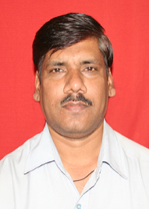

1. Name : Swami P.S.

2. Date of Birth: 10/06/1966
3. Office Address: Department of Electrical Engineering,Govt.College
of Engineering,aurangabad
Email: psswami@rediffmail.com Phone No: 02402366224
4. Educational Background:

- B.E. Electrcial First Class Marathawada University,Aurangabad
M.E. Electrical Power system First Class Amravati University,Amravati
Ph.D. Electrical (pursuing) Dr.B.A.Marathawada University,Aurangabad
5. Area of Research Interests:

- Power System

6. Work Experience:

- __Teaching : 24 year

Total Experience = _24____________

7. Professional Summary:

8. Student Guidance:

- B.E. Projects : _120
- M.E. Projects : 28

9. Administrative responsibilities shared / positions held at GECA :
Hostel Warden
DCOE
Lab.I/c Electrical Measurement

10. Publications:
- International Journals: 08
- International Conferences:__10__
- National Conferences: __08_____
Total:__26_____

11. Membership of Professional Institutions/Organizations:

- ISTE

