Curriculum Vitae

1. Name:_Mrs. Vijaya Sanjay Rajguru 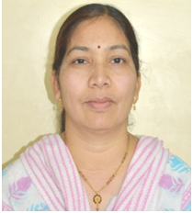

2. Date of Birth: 02-07-1967

3. Office Address: Government Engineering College Aurangabad

Email: vsrajguru2867@gmail.com Phone No: 9822849097

4. Educational Background:

- Ph.D.
- M.E Electrical control system

5. Area of Research Interests:

- Modeling of power electronics converters
- Switch mode power supplies and its control
- Design of power supplies for electric vehicle

6. Work Experience:

- 29 years, Teaching

Total Experience = 29 years

7. Professional Summary:

1991-1998 | Lecturer, Govt. Polytechnic
1998-2000 | Head of Dept. Govt. Polytechnic
2000-uptill | Associate Professor
8. Student Guidance:

- B.E. Projects : 25
- M.E. Projects : 35

9. Administrative responsibilities shared / positions held at GECA :

- Worked as a Faculty adviser for B. Tech. Students.
- Worked as a Faculty In-charge for UPS Maintenance at Institute level
- Worked for a consultancy project on UPS solar System at M. & M. Mumbai
- Worked as a Departmental coordinator for UG NBA-2013-14.
- Received MODROB grants of Rs. 8.00 Lakhs from AICTE.
- Worked as a selection committee member for post of lecturer under Pune University.
10. Publications:
- International Journals:01
- National Journals: 01
- International Conferences:10
- National Conferences: 3
Total:15

11. Membership of Professional Institutions/Organizations:

- LM of ISTE
- _________________________________________________________________
- _________________________________________________________________

