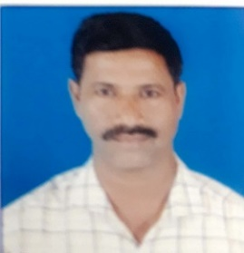
Photo
Name: Shete Umakant N.

Designation: Associate Professor

Department: Mechanical Engineering Department.

Email: susu2005@rediffmail.com

Phone Number: 09422581824

Teaching Experience: 17 yrs.

Qualifications:
Sr.No. | Course | Name of University/Institute | Year
1. | Ph. D. | IIT Roorkee | Pursuing
2. | M.Tech (Thermal power Engg.) | VTU,Belgaum | 2005
3. | B.E. | Dr.B.A.Marthawada,Aurangabad | 1995

Teaching Responsibility:

Subjects Taught at UG level:

1.Engineering Thermodynamics 2. Heat and Mass transfer 3. Thermal and fluid Power Engineering 4.Turbomachinery 5.Engineering Graphics.

Subjects Taught at PG level: NIL
Additional Responsibility: NIL

Publications: NIL

Sr.  No. | Authors | Title of the Paper | Conference/Journal | Institute/Organization | Date
1.

2.

3.
Memberships and Affiliations: NIL
Sr. No. | Organization | Type of membership | Membership details (no. & date)
1
2

